**Assignment -1**

| Assignment Date | 24 September 2022 |
| --- | --- |
| Student Name | Divya Rani.R |
| Student Roll Number | 111619104024 |
| Maximum Marks | 2 Marks |

**Question-1:**

Split the String

s = "Hi there Sam!"

**Solution**:

s.split()

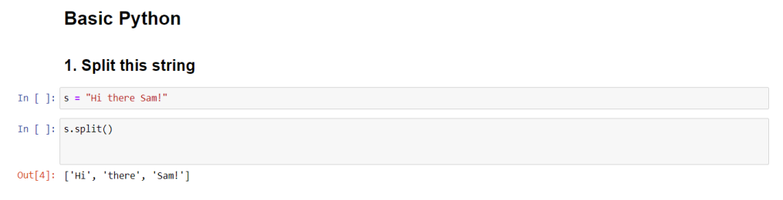**Question-2:**

Use .format() to print the following String

Output should be: The Diameter of Earth is 12742 Kilometers

**Solution :**

planet = "Earth"

diameter = 12742

print('The diameter of {} is {} kilometers.' . format(planet,diameter));

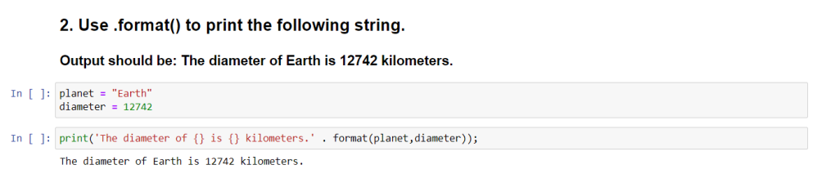

**Question-3:**

In this nest dictionary grab the word “hello”

**Solution :**

d = {'k1':[1,2,3,{'tricky':['oh','man','inception',{'target':[1,2,3,'hello'] }]}]} d['k1'][3]['tricky'][3]['target'][3]

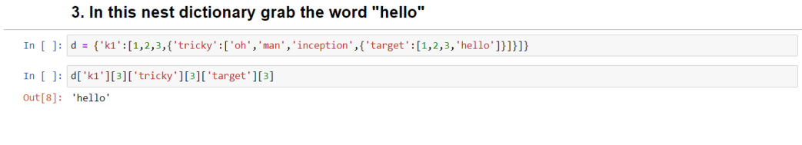**Question-4:**

4.1 Create an array of 10 zeros?

4.2 Create an array of 10 Fives?

**Solution :**

import numpy as np

**4.1** a = np.zeros(10)

a

**4.2** tmp=np.ones(10)*5

print(tmp)

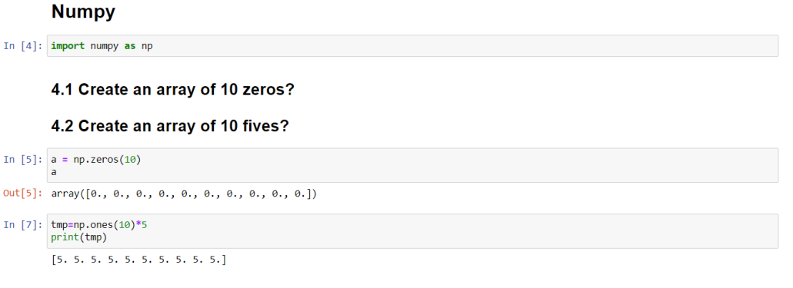

**Question-5:**

Create an array of all the even integers from 20 to 35

**Solution :**

print(np.arange(20,35,2))

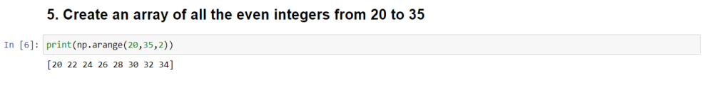**Question-6:**

Create a 3*3 matrix with values raging from 0 to 8

**Solution:**

c = np.arange(0,9).reshape(3,3)

c

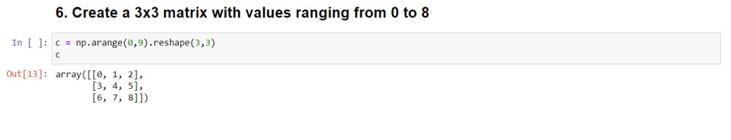**Question-7:**

Concatenate a and b

a= np.([1,2,3]), b=np.array([4,5,6])

**Solution:**

a = np.array([1,2,3])

b = np.array([4,5,6])

np.concatenate((a,b),axis=0)

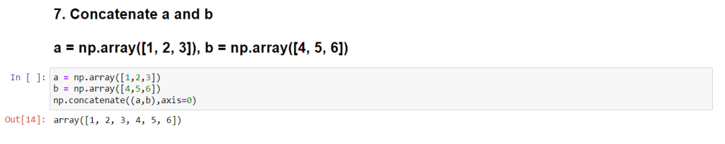

**Pandas**

**Question-8:**

Create a DataFrame with 3 rows and 2 columns

**Solution:**

import pandas as pd

d = {"fruits":["mango","orange","apple"],"color":["yellow","orange","red"]} df = pd.DataFrame(d)

df

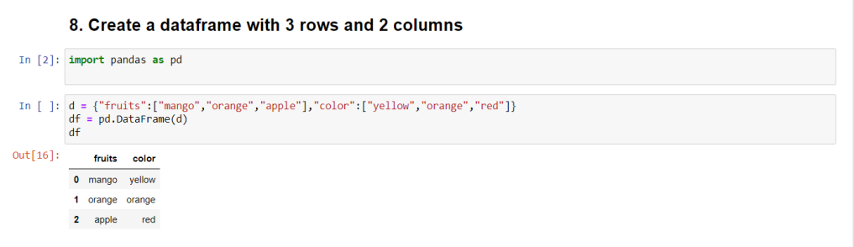

**Question-9:**

Generate the series of dates from 1st Jan,2023 to 10th feb,2023

**Solution:**

dates = pd.date_range(start='1/1/2023',end='2/10/2023')

lists = []

for i in dates:

lists.append(i.strftime('%d-%m-%y'))

print(lists)

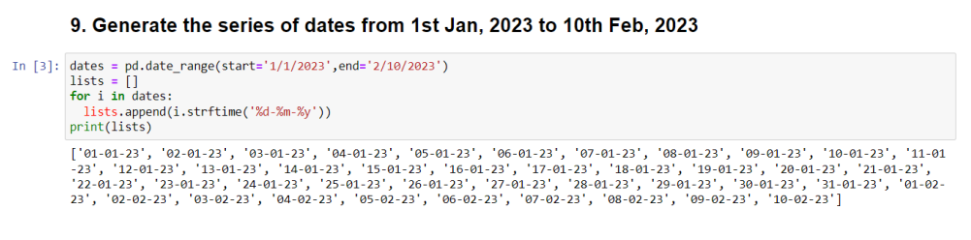

**Question-10:**

Create 2D list to DataFrame

lists = [[1, 'aaa', 22], [2, 'bbb', 25], [3, 'ccc', 24]]

**Solution:**

lists = [[1, 'aaa', 22], [2, 'bbb', 25], [3, 'ccc', 24]]

